1. About Hoa Sen Group

Hoa Sen Group is a prominent Vietnamese firm that focuses on producing and selling steel items. Since its establishment in 2001, the company has expanded considerably and is now one of the most significant steel manufacturers in Vietnam, operating in both local and global markets. Hoa Sen Group has gained recognition for its exceptional standards, inventive approaches, and effective practices, and has diversified its operations to include other sectors such as real estate, renewable energy, and logistics. The purpose of this study is to assess and predict Hoa Sen Group's quarterly gross sales revenue, which will offer valuable insights into the company's performance and assist in forecasting its stock price.

2. Gross sales Revenue

This study collected data about gross sales revenue in 59 quarters (from 2008 to the third quarter of 2022) from the group’s financial report

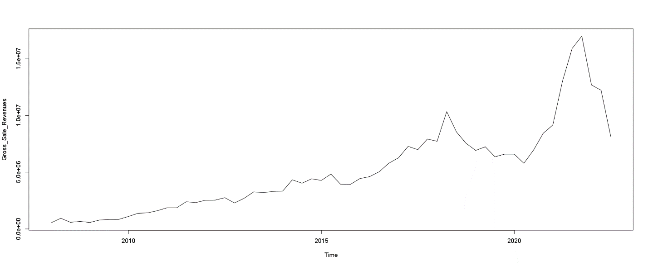

This time series line shows the gross sales revenue of Hoa Sen Group over a period of 14 years, from 2008 to the third quarter of 2022. The data indicates that the company has experienced fluctuations in revenue, with some years showing significant growth while others experiencing declines. Overall, the trend appears to be positive, with revenue increasing steadily until 2017, and then experiencing a slight dip in the following years before rebounding to a new high in 2021. The decline in overall sales was attributed to lower demand both domestically and internationally, as well as rising costs of materials, exchange rates, and interest rates. Despite the negative impact of the Covid-19 pandemic, HSG experienced its most successful year in terms of gross revenue in 2021, reaching VND 17,005 trillion, the highest amount in the history of the company.

Forecast by trend model:

|  |  |  |  |  |  |
| --- | --- | --- | --- | --- | --- |
| Model | R-square | RMSE | MAPE | RMSE (4 last obs) | MAPE (4 last obs) |
| Model 1: Linear time trend (series ~ time) $$GSR_{t}= -910964+200429t$$ | 0.805 | 1678583 | 26.67% | 3856930 | 25.72% |
| Model 2: log-linear time trend (log(series) ~ time) $$\log\left(GSR_{t}\right)=13.616+0.05t$$ | 0.905 | 1787341 | 24.65% | 4383221 | 36.14% |
| Model 3: linear trend + seasonality (additive form) (series ~ time + seas) $$GSR_{t}= -1096173+200406t+448589s_{2}+25864s_{3}+275050s_{4}$$ | 0.8076 | 1668207 | 30.81% | 3794262 | 24.92% |
| Model 4: log-linear trend + seasonality (additive form) (log(series) ~ time + seas) $$GSR_{t}= 13.571+0.05t+0.109s_{2}+0.016s_{3}+0.054s_{4}$$ | 0.9073 | 1773465 | 24.4% | 4313139 | 35.41% |
| Model 5: linear trend + seasonality (multiplicative form) (series ~ time * seas) $$GSR_{t}= -678225+185994t-62085s_{2} -77259s_{3}-935890s_{4}+17503 s_{2}t +4256 s_{3}t+40845 s_{4}t$$ | 0.8123 | 1647871 | 29.95% | 3515962 | 23.66% |

Overall, all five models have relatively high R-squared values, indicating a good fit to the data. However, the RMSE and MAPE values differ between the models. Model 4: (log-linear trend + seasonality) has the lowest MAPE value in case of all dataset, indicating the smallest average percentage error between actual and predicted values. However, it has the highest RMSE value among all the models. Model 2: (log-linear time trend) has the second-lowest MAPE value but a higher RMSE value compared to Model 4, indicating that it is a good choice for forecasting gross sales revenue.

In other hand, when we compare MAPE of these models in 4 last observations, there is huge different. Model 5 (linear trend + seasonality in multiplicative form) has the lowest RMSE (3515962) and MAPE (23.66%) values, indicating that it is the most accurate model among all other models in predicting the series values for the last four observations. Following up, Model 3 (linear trend + seasonality in additive form) also performs well, with an RMSE of 3794262 and an MAPE of 24.92%, which is very close to the performance of Model 5. In general, model 4 appears to have the best overall fit for the dataset, but when considering only the last 4 observations, model 5 exhibits the highest level of accuracy.

Holt-Winter model:

|  |  |  |  |  |
| --- | --- | --- | --- | --- |
| Model | RMSE | MAPE | RMSE (4 last obs) | MAPE (4 last obs) |
| Model 6: Holt-Winter Additive form | 1138826 | 15.73% | 2935848 | 23.78% |
| Model 7: Holt-Winter Multiplicative form | 1027275 | 15.77% | 2593691 | 17.77% |

Decompose model:

Decomposition of Gross Sale Revenue series (additive):

|  |  |
| --- | --- |
|  | In general, we can see that the gross sale revenue has increased over time, with some fluctuations along the way. From 2008 to 2010, the values increased steadily, followed by a sharper increase from 2011 to 2017. After a dip in 2018 and 2019, the values increased again in 2020 and 2021.  The seasonal series highlights that the gross sales revenue is heavily influenced by Q1 and Q2, with Q1 showing a significant decrease of around -281879 and Q2 indicating a sharp increase of approximately 208681. This suggests that there is a substantial drop in demand during Q1, followed by a substantial surge in demand in Q2. |

We remove the seasonal impact from the time series and retain only the trend and random factors. This will yield a Seasonal Adjustment series, which we can use to construct a regression model. Since the model is a seasonally adjusted model, it is necessary to incorporate the decomposed seasonal factor when making predictions or computing metrics such as RMSE and MAPE.

|  |  |  |  |  |  |
| --- | --- | --- | --- | --- | --- |
| Model | R-square | RMSE | MAPE | RMSE (4 last obs) | MAPE (4 last obs) |
| Model 8: Additive seasonal adjustment ~ time | 0.8062 | 1671357 | 30.74% | 3857107 | 25.79% |

